**Rani Channamma  University Belagavi**



**B.L.D.E ASSOCIATION’S**

**S.B ARTS AND K.C.P SCIENCE COLLEGE, VIJAYAPUR**

**DEPARTMENT OF PG STUDIES IN Computer Science**

**2020-2021**

**Mini-Project on**

**Grocery Store Management**

**Under the Guidance of**

**Prof.Pavan M**

**Submitted By**

**Prasad Merwade**

**(CS201205)**

**Rani Channamma**  **University, Belagavi**

**B.L.D.E. ASSOCIATION’S**

**S.B. ARTS AND K.C.P SCIENCE COLLEGE VIJAYAPUR**

**DECLARATION**

**RANI CHANNAMMA** **UNIVERSITY BELAGAVI**



**B.L.D.E. ASSOCIATION’S**

**S.B.ARTS AND K.C.P SCIENCE COLLEGE VIJAYAPUR**

**DEPARTMENT OF PG STUDIES IN PHYSICS**

**CERTIFICATE**

This is to certify that the project entitled

**Grocery Store Management**

*Is being**submitted* *by* **PRASAD S MERWADE** Register number **CS201205** *for* *the award of degree* *in* **MASTER OF SCIENCE IN Computer Science** *by the* **RANI CHANNAMMA UNIVERSITY, BELAGAVI,** *as bonafied record of the project work carried out by him under our supervision for the academic year* ***2020-2021*.**

Guide Co-ordinator Principal

**ACKNOWLEDGEMENT**

# Content

1. Introduction
   1. Purpose of this documentation
   2. Overview
2. General Description
   1. Product Function
   2. Intended User
3. Functional Requirements
4. User Interface
5. Software/Hardware Requirements
6. Technologies
7. use case diagram
8. code
9. Test Case
10. Conclusion and Future Scope
11. **Introduction** 
    1. Purpose of this document

Overview of this project along with functionalities, intended users, user interface and software requirements

* 1. Overview

Supermarket management system is the system where all the aspects related to the proper management of supermarkets are done. These aspects involve managing information about the various products, staff, customers, billing etc. This system provides an efficient way of managing the supermarket information.

This project is based on the sales transaction and billing of items in a supermarket. The first activity is based on adding the items to the system along with the rate which are present in the supermarket and the name of the items which the supermarket will agree to sell. This authority is given only to the product manager. Any modifications to be done in the item name and the rate can be done only by him. He also has the right to delete any item. As the customer buys the products and comes to the billing counter, the user is supposed to enter the item name he purchased and the quantity of the item he had purchased.

1. **General Description**
   1. Product Functions

* Maintain record of all the products sold in the store.
* Monitor stock of different products.
* Add or remove products, remove expired products.
* Bill generation.
  1. Intended Users
* Store Admin
* Sales Man

1. **Functional Requirements**
   * + - Login for admin
       - Logout Functionality
       - Manage Categories

Add Categories

Update Categories

Delete Categories

* + - * Manage Seller

Add

Remove

* + - * Manage Products

Add Products

Update Products

Delete Products

1. **User Interface**

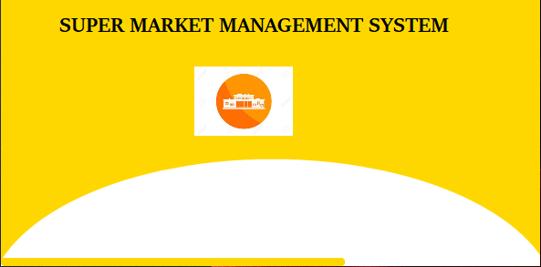

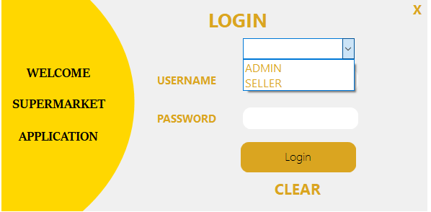

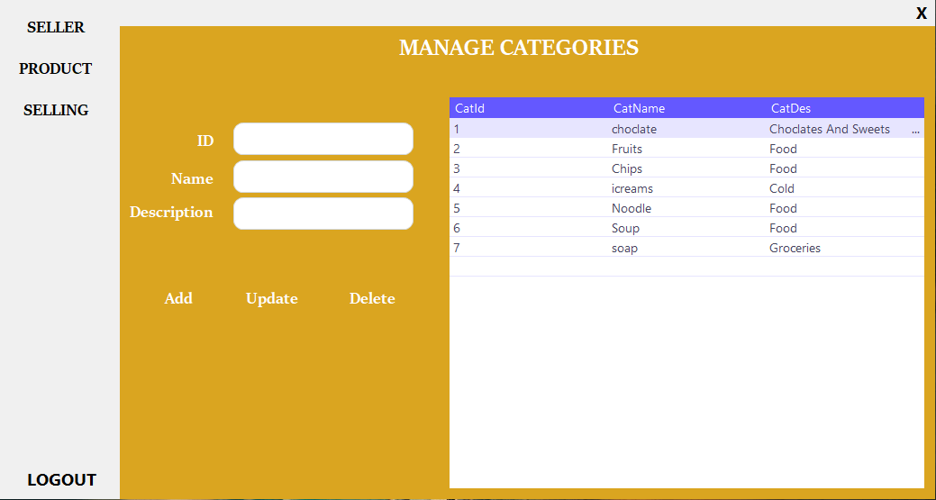

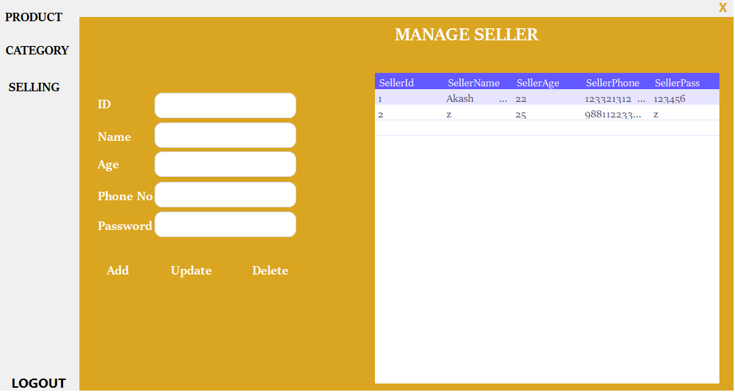

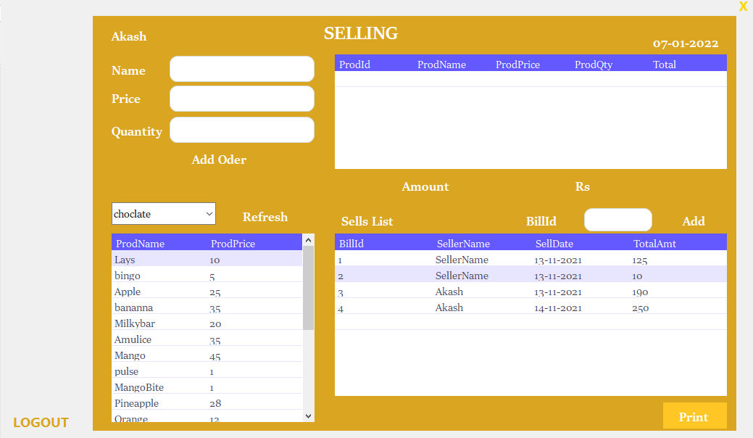

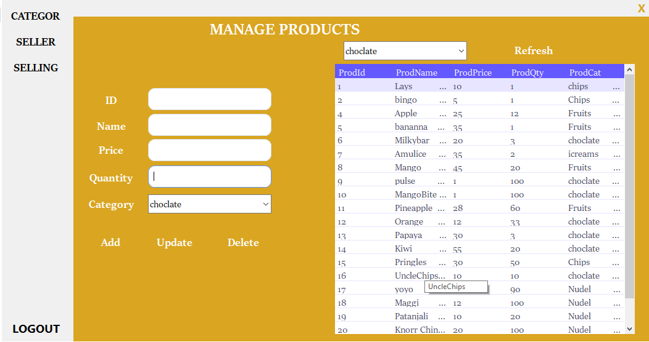

1. **Software/Hardware Requirements**

* Windows 10 or Older
* Ram 4gb or more
* Hard Disk

1. **Technologies**

* Visual Studio 2017
* Windows Form
* C#
* Microsoft Sql Server

1. **use case diagram**

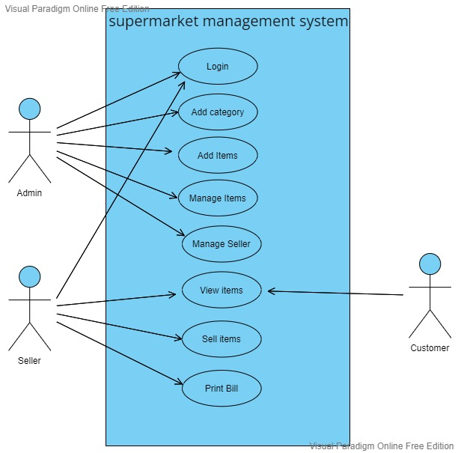

1. **Code**

**Splash Page:**

public partial class SplashForm : Form

{

public SplashForm()

{

InitializeComponent();

}

private void guna2CircleProgressBar1_ValueChanged(object sender, EventArgs e)

{

}

int startPoint = 0;

private void timer1_Tick(object sender, EventArgs e)

{

startPoint += 2;

myProgressBar.Value = startPoint;

if(myProgressBar.Value==100)

{

myProgressBar.Value = 0;

timer1.Stop();

Form1 form = new Form1();

this.Hide();

form.Show();

}

}

private void SplashForm_Load(object sender, EventArgs e)

{

timer1.Start();

}

}

}

**Form Page:**

public partial class Form1 : Form

{

DBConnect dBCon = new DBConnect();

public static string sellerName;

public Form1()

{

InitializeComponent();

}

private void label_exit_Click(object sender, EventArgs e)

{

Application.Exit();

}

private void label_exit_MouseEnter(object sender, EventArgs e)

{

label_exit.ForeColor = Color.Red;

}

private void label_exit_MouseLeave(object sender, EventArgs e)

{

label_exit.ForeColor = Color.Goldenrod;

}

private void label_clear_MouseEnter(object sender, EventArgs e)

{

label_clear.ForeColor = Color.Red;

}

private void label_clear_MouseLeave(object sender, EventArgs e)

{

label_clear.ForeColor = Color.Goldenrod;

}

private void label_clear_Click(object sender, EventArgs e)

{

TextBox_username.Clear();

TextBox_password.Clear();

}

private void Button_login_Click(object sender, EventArgs e)

{

if (TextBox_username.Text == "" || TextBox_password.Text == "")

{

MessageBox.Show("Please Enter the Username and Password", "Missing Information", MessageBoxButtons.OK, MessageBoxIcon.Error);

}

else

{

if (comboBox_role.SelectedIndex > -1)

{

if (comboBox_role.SelectedItem.ToString() == "ADMIN")

{

if (TextBox_username.Text == "Admin" && TextBox_password.Text == "Admin123")

{

ProductForm product = new ProductForm();

product.Show();

this.Hide();

}

else

{

MessageBox.Show("If you are Admin, Please enter the correctId and Password", "Miss Id", MessageBoxButtons.OK, MessageBoxIcon.Warning);

}

}

else

{

string selectQuery = "SELECT * FROM Seller WHERE SellerName='" + TextBox_username.Text + "' And SellerPass='" + TextBox_password.Text + "' ";

SqlDataAdapter adapter = new SqlDataAdapter(selectQuery, dBCon.getCon());

DataTable table = new DataTable();

adapter.Fill(table);

if (table.Rows.Count > 0)

{

sellerName = TextBox_username.Text;

SellingForm selling = new SellingForm();

selling.Show();

this.Hide();

}

else

{

MessageBox.Show("Wrong UserName or Password", "Wrong Information", MessageBoxButtons.OK, MessageBoxIcon.Error);

}

}

}

else

{

MessageBox.Show("Please select role", "Wrong Information ", MessageBoxButtons.OK, MessageBoxIcon.Warning);

}

}

}

}

}

**Category Form:**

public partial class CategoryForm : Form

{

DBConnect dBCon = new DBConnect();

public CategoryForm()

{

InitializeComponent();

}

private void getTable()

{

string selectQuerry = "SELECT * FROM CAtegory ";

SqlCommand command = new SqlCommand(selectQuerry, dBCon.getCon());

SqlDataAdapter adapter = new SqlDataAdapter(command);

DataTable table = new DataTable();

adapter.Fill(table);

DataGridView_categorie.DataSource = table;

}

private void button_add_Click(object sender, EventArgs e)

{

try

{

string insertQuery = "INSERT INTO CAtegory VALUES(" + TextBox_id.Text + ",'" + TextBox_name.Text + "','" + TextBox_description.Text + "')";

SqlCommand command = new SqlCommand(insertQuery, dBCon.getCon());

dBCon.OpenCon();

command.ExecuteNonQuery();

MessageBox.Show("Category Added Sucessfully ","Add Information",MessageBoxButtons.OK,MessageBoxIcon.Information);

dBCon.CloseCon();

getTable();

clear();

} catch (Exception ex)

{

MessageBox.Show(ex.Message);

}

}

private void CategoryForm_Load(object sender, EventArgs e)

{

getTable();

}

private void button_update_Click(object sender, EventArgs e)

{

try

{

if (TextBox_id.Text == "" || TextBox_name.Text == "" || TextBox_description.Text == "")

{

MessageBox.Show("Missing Information", "Warning", MessageBoxButtons.OK, MessageBoxIcon.Error);

}

else

{

string updateQuery = "UPDATE CAtegory SET CatName='" + TextBox_name.Text + "',CatDes='" + TextBox_description.Text + "' WHERE CatId=" + TextBox_id.Text + " ";

SqlCommand command = new SqlCommand(updateQuery, dBCon.getCon());

dBCon.OpenCon();

command.ExecuteNonQuery();

MessageBox.Show("Category Updated Sucessfully ", "Update Information", MessageBoxButtons.OK, MessageBoxIcon.Information);

dBCon.CloseCon();

getTable();

clear();

}

}

catch(Exception ex)

{

MessageBox.Show(ex.Message);

}

}

private void DataGridView_categorie_Click(object sender, EventArgs e)

{

TextBox_id.Text = DataGridView_categorie.SelectedRows[0].Cells[0].Value.ToString();

TextBox_name.Text = DataGridView_categorie.SelectedRows[0].Cells[1].Value.ToString();

TextBox_description.Text = DataGridView_categorie.SelectedRows[0].Cells[2].Value.ToString();

}

private void clear()

{

TextBox_id.Clear();

TextBox_name.Clear();

TextBox_description.Clear();

}

private void button_delete_Click(object sender, EventArgs e)

{

try

{

string deleteQuery = "DELETE FROM CAtegory WHERE CatId= " + TextBox_id.Text + "";

SqlCommand command = new SqlCommand(deleteQuery, dBCon.getCon());

dBCon.OpenCon();

command.ExecuteNonQuery();

MessageBox.Show("Category Deleted Sucessfully ", "Delete Information", MessageBoxButtons.OK, MessageBoxIcon.Information);

dBCon.CloseCon();

getTable();

clear();

}catch(Exception ex)

{

MessageBox.Show(ex.Message);

}

}

private void label_exit_Click(object sender, EventArgs e)

{

Application.Exit();

}

private void label_exit_MouseEnter(object sender, EventArgs e)

{

label_exit.ForeColor = Color.Red;

}

private void label_exit_MouseLeave(object sender, EventArgs e)

{

label_exit.ForeColor = Color.Goldenrod;

}

private void label_logout_MouseEnter(object sender, EventArgs e)

{

label_logout.ForeColor = Color.Red;

}

private void label_logout_MouseLeave(object sender, EventArgs e)

{

label_logout.ForeColor = Color.Goldenrod;

}

private void label_logout_Click(object sender, EventArgs e)

{

Form1 login = new Form1();

login.Show();

this.Hide();

}

private void button_product_Click(object sender, EventArgs e)

{

ProductForm product = new ProductForm();

product.Show();

this.Hide();

}

private void button_seller_Click(object sender, EventArgs e)

{

SellerForm seller = new SellerForm();

seller.Show();

this.Hide();

}

}

}

**Seller Form:**

namespace mini_Market_Management_System

{

public partial class SellerForm : Form

{

DBConnect dBCon = new DBConnect();

public SellerForm()

{

InitializeComponent();

}

private void getTable()

{

string selectQuerry = "SELECT * FROM Seller ";

SqlCommand command = new SqlCommand(selectQuerry, dBCon.getCon());

SqlDataAdapter adapter = new SqlDataAdapter(command);

DataTable table = new DataTable();

adapter.Fill(table);

DataGridView_Seller.DataSource = table;

}

private void clear()

{

TextBox_id.Clear();

TextBox_name.Clear();

TextBox_age.Clear();

TextBox_phone.Clear();

TextBox_pass.Clear();

}

private void label_exit_Click(object sender, EventArgs e)

{

Application.Exit();

}

private void label3_Click(object sender, EventArgs e)

{

}

private void button_add_Click(object sender, EventArgs e)

{

try

{

string insertQuery = "INSERT INTO Seller VALUES (" + TextBox_id.Text + ",'" + TextBox_name.Text + "','" + TextBox_age.Text + "','" + TextBox_phone.Text + "','" + TextBox_pass.Text+ "')";

SqlCommand command = new SqlCommand(insertQuery, dBCon.getCon());

dBCon.OpenCon();

command.ExecuteNonQuery();

MessageBox.Show("Product Added Sucessfully ", "Add Information", MessageBoxButtons.OK, MessageBoxIcon.Information);

dBCon.CloseCon();

getTable();

clear();

}

catch (Exception ex)

{

MessageBox.Show(ex.Message);

}

}

private void SellerForm_Load(object sender, EventArgs e)

{

getTable();

}

private void button_update_Click(object sender, EventArgs e)

{

try

{

if (TextBox_id.Text == "" || TextBox_name.Text == "" || TextBox_age.Text == "" || TextBox_phone.Text == "" || TextBox_pass.Text == "")

{

MessageBox.Show("Missing Information", "Missing Information", MessageBoxButtons.OK, MessageBoxIcon.Error);

}

else

{

string updateQuery = "UPDATE Seller SET SellerName='" + TextBox_name.Text + "',SellerAge='" + TextBox_age.Text + "',SellerPhone='" + TextBox_phone.Text + "',SellerPass='" + TextBox_pass.Text + "'WHERE SellerId=" + TextBox_id.Text + " ";

SqlCommand command = new SqlCommand(updateQuery, dBCon.getCon());

dBCon.OpenCon();

command.ExecuteNonQuery();

MessageBox.Show("Seller Updated Sucessfully ", "Update Information", MessageBoxButtons.OK, MessageBoxIcon.Information);

dBCon.CloseCon();

getTable();

clear();

}

}

catch (Exception ex)

{

MessageBox.Show(ex.Message);

}

}

private void DataGridView_Seller_Click(object sender, EventArgs e)

{

TextBox_id.Text = DataGridView_Seller.SelectedRows[0].Cells[0].Value.ToString();

TextBox_name.Text= DataGridView_Seller.SelectedRows[0].Cells[1].Value.ToString();

TextBox_age.Text= DataGridView_Seller.SelectedRows[0].Cells[2].Value.ToString();

TextBox_phone.Text= DataGridView_Seller.SelectedRows[0].Cells[3].Value.ToString();

TextBox_pass.Text= DataGridView_Seller.SelectedRows[0].Cells[4].Value.ToString();

}

private void button_delete_Click(object sender, EventArgs e)

{

try

{

if (TextBox_id.Text == "")

{

MessageBox.Show("Missing Information", "Missing Information", MessageBoxButtons.OK, MessageBoxIcon.Error);

}

else

{

if (MessageBox.Show("Are you sure you want to delete thos record?", "Delete Record", MessageBoxButtons.YesNo, MessageBoxIcon.Question) == DialogResult.Yes)

{

string deleteQuery = "DELETE FROM Seller WHERE SellerId=" + TextBox_id.Text + "";

SqlCommand command = new SqlCommand(deleteQuery, dBCon.getCon());

dBCon.OpenCon();

command.ExecuteNonQuery();

MessageBox.Show("Seller Deleted Sucessfully ", "Delete Information", MessageBoxButtons.OK, MessageBoxIcon.Information);

dBCon.CloseCon();

getTable();

clear();

}

}

}

catch (Exception ex)

{

MessageBox.Show(ex.Message);

}

}

private void label_logout_MouseEnter(object sender, EventArgs e)

{

label_logout.ForeColor = Color.Red;

}

private void label_exit_MouseEnter(object sender, EventArgs e)

{

label_exit.ForeColor = Color.Red;

}

private void label_logout_Click(object sender, EventArgs e)

{

Form1 login = new Form1();

login.Show();

this.Hide();

}

private void button_Product_Click(object sender, EventArgs e)

{

ProductForm product = new ProductForm();

product.Show();

this.Hide();

}

private void button_category_Click(object sender, EventArgs e)

{

CategoryForm category = new CategoryForm();

category.Show();

this.Hide();

}

}

}

**Selling Form:**

int grandTotal = 0, n = 0;

private void button_add_Click(object sender, EventArgs e)

{

if (TextBox_name.Text == "" || TextBox_qty.Text == "")

{

MessageBox.Show("Missing Information", "Information Error", MessageBoxButtons.OK, MessageBoxIcon.Warning);

}

else

{

int Total = Convert.ToInt32(TextBox_price.Text) * Convert.ToInt32(TextBox_qty.Text);

DataGridViewRow addRow = new DataGridViewRow();

addRow.CreateCells(DataGridView_oder);

addRow.Cells[0].Value = ++n;

addRow.Cells[1].Value = TextBox_name.Text;

addRow.Cells[2].Value = TextBox_price.Text;

addRow.Cells[3].Value = TextBox_qty.Text;

addRow.Cells[4].Value = Total;

DataGridView_oder.Rows.Add(addRow);

grandTotal += Total;

label_amount.Text = grandTotal + " Rs";

}

}

private void getCategory()

{

string selectQuerry = "SELECT * FROM CAtegory ";

SqlCommand command = new SqlCommand(selectQuerry, dBCon.getCon());

SqlDataAdapter adapter = new SqlDataAdapter(command);

DataTable table = new DataTable();

adapter.Fill(table);

comboBox_category.DataSource = table;

comboBox_category.ValueMember = "CatName";

}

private void getTable()

{

string selectQuerry = "SELECT ProdName, ProdPrice FROM Product ";

SqlCommand command = new SqlCommand(selectQuerry, dBCon.getCon());

SqlDataAdapter adapter = new SqlDataAdapter(command);

DataTable table = new DataTable();

adapter.Fill(table);

DataGridView_product.DataSource = table;

}

private void getSellTable()

{

string selectQuerry = "SELECT * FROM Bill";

SqlCommand command = new SqlCommand(selectQuerry, dBCon.getCon());

SqlDataAdapter adapter = new SqlDataAdapter(command);

DataTable table = new DataTable();

adapter.Fill(table);

DataGridView_sellList.DataSource = table;

}

private void SellingForm_Load(object sender, EventArgs e)

{

label_date.Text = DateTime.Today.ToShortDateString();

label_seller.Text = Form1.sellerName;

getTable();

getCategory();

getSellTable();

}

private void button_print_Click(object sender, EventArgs e)

{

printer.Title = "Prasads Super Market Lists";

printer.SubTitle = string.Format("Date:{0}", DateTime.Now.Date);

printer.SubTitleFormatFlags = StringFormatFlags.LineLimit | StringFormatFlags.NoClip;

printer.PageNumbers = true;

printer.PageNumberInHeader = false;

printer.PorportionalColumns = true;

printer.HeaderCellAlignment = StringAlignment.Near;

printer.Footer = "foxlearn";

printer.FooterSpacing = 15;

printer.printDocument.DefaultPageSettings.Landscape = true;

printer.PrintDataGridView(DataGridView_sellList);

}

private void button_add_Click_1(object sender, EventArgs e)

{

try

{

string insertQuery = "INSERT INTO Bill VALUES (" + TextBox_id.Text + ",'" + label_seller.Text + "','" + label_date.Text + "'," + grandTotal.ToString()+ ")";

SqlCommand command = new SqlCommand(insertQuery, dBCon.getCon());

dBCon.OpenCon();

command.ExecuteNonQuery();

MessageBox.Show("Order Added Sucessfully ", "Order Information", MessageBoxButtons.OK, MessageBoxIcon.Information);

dBCon.CloseCon();

getSellTable();

}

catch (Exception ex)

{

MessageBox.Show(ex.Message);

}

}

private void label_logout_Click(object sender, EventArgs e)

{

Form1 login = new Form1();

login.Show();

this.Hide();

}

private void label_exit_Click(object sender, EventArgs e)

{

Application.Exit();

}

private void label_exit_MouseEnter(object sender, EventArgs e)

{

label_exit.ForeColor = Color.Red;

}

private void label_exit_MouseLeave(object sender, EventArgs e)

{

label_exit.ForeColor = Color.Goldenrod;

}

private void label_logout_MouseEnter(object sender, EventArgs e)

{

label_logout.ForeColor = Color.Red;

}

private void label_logout_MouseLeave(object sender, EventArgs e)

{

label_logout.ForeColor = Color.Goldenrod;

}

private void guna2Button1_Click(object sender, EventArgs e)

{

getTable();

}

private void comboBox_category_SelectionChangeCommitted(object sender, EventArgs e)

{

string selectQuerry = "SELECT ProdName, ProdPrice FROM Product WHERE ProdCat='" + comboBox_category.SelectedValue.ToString() + "' ";

SqlCommand command = new SqlCommand(selectQuerry, dBCon.getCon());

SqlDataAdapter adapter = new SqlDataAdapter(command);

DataTable table = new DataTable();

adapter.Fill(table);

DataGridView_product.DataSource = table;

}

private void DataGridView_product_Click(object sender, EventArgs e)

{

TextBox_name.Text = DataGridView_product.SelectedRows[0].Cells[0].Value.ToString();

TextBox_price.Text= DataGridView_product.SelectedRows[0].Cells[1].Value.ToString();

}

}

}

**Product Form:**

namespace mini_Market_Management_System

{

public partial class ProductForm : Form

{

DBConnect dBCon = new DBConnect();

public ProductForm()

{

InitializeComponent();

}

private void button1_Click(object sender, EventArgs e)

{

getTable();

}

private void button_category_Click(object sender, EventArgs e)

{

CategoryForm category = new CategoryForm();

category.Show();

this.Hide();

}

private void ProductForm_Load(object sender, EventArgs e)

{

getCategory();

getTable();

}

private void getCategory()

{

string selectQuerry = "SELECT * FROM CAtegory ";

SqlCommand command = new SqlCommand(selectQuerry, dBCon.getCon());

SqlDataAdapter adapter = new SqlDataAdapter(command);

DataTable table = new DataTable();

adapter.Fill(table);

comboBox_category.DataSource = table;

comboBox_category.ValueMember = "CatName";

comboBox_search.DataSource = table;

comboBox_search.ValueMember = "CatName";

}

private void getTable()

{

string selectQuerry = "SELECT * FROM Product ";

SqlCommand command = new SqlCommand(selectQuerry, dBCon.getCon());

SqlDataAdapter adapter = new SqlDataAdapter(command);

DataTable table = new DataTable();

adapter.Fill(table);

DataGridView_p.DataSource = table;

}

private void clear()

{

TextBox_id.Clear();

TextBox_name.Clear();

TextBox_price.Clear();

TextBox_qty.Clear();

comboBox_category.SelectedIndex = 0;

}

private void label_exit_Click(object sender, EventArgs e)

{

Application.Exit();

}

private void button_add_Click(object sender, EventArgs e)

{

try

{

string insertQuery = "INSERT INTO Product VALUES (" + TextBox_id.Text + ",'" + TextBox_name.Text + "'," + TextBox_price.Text + "," + TextBox_qty .Text+ ",'" + comboBox_category.Text + "')";

SqlCommand command = new SqlCommand(insertQuery, dBCon.getCon());

dBCon.OpenCon();

command.ExecuteNonQuery();

MessageBox.Show("Product Added Sucessfully ", "Add Information", MessageBoxButtons.OK, MessageBoxIcon.Information);

dBCon.CloseCon();

getTable();

clear();

}

catch (Exception ex)

{

MessageBox.Show(ex.Message);

}

}

private void button_update_Click(object sender, EventArgs e)

{

try

{

if (TextBox_id.Text == "" || TextBox_name.Text == "" || TextBox_price.Text == "" || TextBox_qty.Text == "")

{

MessageBox.Show("Missing Information", "Missing Information", MessageBoxButtons.OK, MessageBoxIcon.Error);

}

else

{

string updateQuery = "UPDATE Product SET ProdName='" + TextBox_name.Text + "',ProdPrice=" + TextBox_price.Text + ",ProdQty=" + TextBox_qty.Text + ",ProdCat='" + comboBox_category.Text + "'WHERE ProdId=" + TextBox_id.Text + " ";

SqlCommand command = new SqlCommand(updateQuery, dBCon.getCon());

dBCon.OpenCon();

command.ExecuteNonQuery();

MessageBox.Show("Product Updated Sucessfully ", "Update Information", MessageBoxButtons.OK, MessageBoxIcon.Information);

dBCon.CloseCon();

getTable();

clear();

}

}

catch(Exception ex)

{

MessageBox.Show(ex.Message);

}

}

private void DataGridView_p_Click(object sender, EventArgs e)

{

TextBox_id.Text = DataGridView_p.SelectedRows[0].Cells[0].Value.ToString();

TextBox_name.Text = DataGridView_p.SelectedRows[0].Cells[1].Value.ToString();

TextBox_price.Text = DataGridView_p.SelectedRows[0].Cells[2].Value.ToString();

TextBox_qty.Text = DataGridView_p.SelectedRows[0].Cells[3].Value.ToString();

comboBox_category.SelectedValue = DataGridView_p.SelectedRows[0].Cells[4].Value.ToString();

}

private void button_delete_Click(object sender, EventArgs e)

{

try

{

if (TextBox_id.Text == "")

{

MessageBox.Show("Missing Information", "Missing Information", MessageBoxButtons.OK, MessageBoxIcon.Error);

}

else

{

string deleteQuery = "DELETE FROM Product WHERE ProdId=" + TextBox_id.Text + "";

SqlCommand command = new SqlCommand(deleteQuery, dBCon.getCon());

dBCon.OpenCon();

command.ExecuteNonQuery();

MessageBox.Show("Product Deleted Sucessfully ", "Delete Information", MessageBoxButtons.OK, MessageBoxIcon.Information);

dBCon.CloseCon();

getTable();

clear();

}

}catch(Exception ex)

{

MessageBox.Show(ex.Message);

}

}

private void comboBox_search_SelectionChangeCommitted(object sender, EventArgs e)

{

string selectQuerry = "SELECT * FROM Product WHERE ProdCat='"+comboBox_search.SelectedValue.ToString()+"' ";

SqlCommand command = new SqlCommand(selectQuerry, dBCon.getCon());

SqlDataAdapter adapter = new SqlDataAdapter(command);

DataTable table = new DataTable();

adapter.Fill(table);

DataGridView_p.DataSource = table;

}

private void label_exit_MouseEnter(object sender, EventArgs e)

{

label_exit.ForeColor = Color.Red;

}

private void label_logout_MouseEnter(object sender, EventArgs e)

{

label_logout.ForeColor = Color.Red;

}

private void label_logout_Click(object sender, EventArgs e)

{

Form1 login = new Form1();

login.Show();

this.Hide();

}

private void button_seller_Click(object sender, EventArgs e)

{

SellerForm seller = new SellerForm();

seller.Show();

this.Hide();

}

}

**Data Base Connection:**

using System;

using System.Collections.Generic;

using System.Linq;

using System.Text;

using System.Threading.Tasks;

using System.Data.SqlClient;

namespace mini_Market_Management_System

{

class DBConnect

{

private SqlConnection connection = new SqlConnection(@"Data Source=(LocalDB)\MSSQLLocalDB;AttachDbFilename=C:\Users\S.T.Merwade\Documents\minimarkettb.mdf;Integrated Security=True;Connect Timeout=30 ");

public SqlConnection getCon()

{

return connection;

}

public void OpenCon()

{

if(connection.State==System.Data.ConnectionState.Closed)

{

connection.Open();

}

}

public void CloseCon()

{

if(connection.State==System.Data.ConnectionState.Open)

{

connection.Close();

}

}

}

}

1. **Test Case**

**Admin-**

|  |  |  |  |  |
| --- | --- | --- | --- | --- |
| Test Case Id | Test Case | Expected Output | Exhibiting Output | Result |
| 1 | No entry in User Name field | It will Show an error message | Please enter user name | Pass |
| 2 | Enter correct username and Password | Admin must login | Admin Page | Pass |

**Employee-**

|  |  |  |  |  |
| --- | --- | --- | --- | --- |
| Test Case Id | Test Case | Expected Output | Exhibiting Output | Result |
| 1 | Entry Correct User Name and Password | Employee login | Employee login  Page open | Pass |

**Conclusion**

The supermarket management system has been successfully implemented. However, there are a lot of improvements that can be done.

**Reference**

* Microsoft Visual C# Step by Step (Ninth Edition), John Sharp
* Grocery Store management (slide share), [Gayatri Patel](https://www.slideshare.net/GayatriPatel27?utm_campaign=profiletracking&utm_medium=sssite&utm_source=ssslideview)
* Online Store detail (Slide Share), Kavita Sharma
* Grocery Store management (Blog)